Comprehensive Software Security Assessment and Vulnerability Disclosure – MediCare Innovations

1. Abstract (150–250 words)
Patient data is stored by healthcare facilities using a lot of digital technologies. Healthcare is made quicker and easier by technologies like wearable health devices, online doctor services, and electronic health records, but they also carry concerns. Sensitive patient information can be stolen or used illegally if not protected. The software security of Medicare Innovations, a company that uses creative healthcare technologies, is studied in this paper, with a focus on issues that could risk patient information.
Several methods were used to identify these issues, ensuring that login credentials were secure, and Wireshark was used to examine network traffic. Common attacks such as buffer overrun and SQL Injection were assessed for in web applications and mobile apps were checked for excessive permission requests and unexplained user tracking. The impact of known software vulnerabilities from the CVE database was also examined along with solutions.
Risks such as, unprotected passwords, vulnerable webpages, permissions requests from mobile apps, and threats from software weaknesses were identified based on the survey. Demonstrating how crucial it is to restrict app access, protecting passwords, and report issues appropriately. By doing this, healthcare systems become more dependable, and patient data is protected.

2. Introduction (400-500 words)
Abernethy et al. (2022) explain that software now underpins almost every aspect of daily life, supporting societal development through the systems that power computers, mobile applications, hospitals, transportation, and banking. As this reliance increases, the importance of software security also grows. Verizon (2025) emphasises that poorly secured software can easily lead to issues such as data theft and system failures. A clear example of this was the 2017 WannaCry ransomware outbreak, which BBC News reported as having affected healthcare systems globally, including the United Kingdom’s National Health Service.
This incident caused major operational disruption, with hospital functions cancelled or diverted, illustrating how software vulnerabilities can result in severe real-world consequences. According to NS Commercial (2025), cyberattacks of this scale are becoming more frequent, with breaches across different industries continuing to rise. The impact of compromised software can be seen in high-profile cases such as the 2017 Equifax breach, which exposed the personal information of more than 147 million individuals (BBC News, 2017).
Security breaches also have significant financial implications. IBM Security (2024) notes that organisations face direct costs related to investigation and remediation, alongside indirect costs such as business disruption and long-term damage. In healthcare, compromised patient information increases risks such as identity theft, fraud, and threats to patient safety. Ensuring strong protection of sensitive medical data is essential not only for regulatory compliance but also for maintaining user trust (NIST, 2018).
This study therefore evaluates the software security of MediCare Innovations by examining four key areas: identifying threats to healthcare data systems, analysing software and web-based attacks, assessing mobile healthcare applications, and reviewing known software vulnerabilities using the CVE database maintained by NIST (2019). The methods applied include analysing password handling and network traffic in Wireshark, assessing online application vulnerabilities, reviewing mobile permission configurations, and researching CVEs to understand their impact and mitigation strategies.

Case 1: Understanding Healthcare Data and Communication System Risks
Task 1:
1.Insecure Communication
Bernstein (2025) states that if patients’ data is not securely encrypted during transfer, then attackers are able to exploit it by engaging in illegal activity within the system, for example, patients test results, medical histories & login credentials would be compromised. These violations can harm the organisation's reputation and weaken patient trust in digital services.
2. Weak Data Privacy Controls
Unauthorised access to personal health information, with risk of patients being hit with fraud or identity theft if hackers take advantage of gaps to steal information, results from poor security measures. Patients may worry that their information is not being properly secured because of incidents like this, which destroys their trust in the healthcare provider (Iott, Campos-Castillo and Anthony, 2020). Patients would be discouraged from providing crucial health information with doctors and from using digital medical platforms.
3. Manipulation of Sensitive Data
If hackers can get a reach of data such as medication records, appointment details and evaluation findings which may be fraudulently changed according to NHS England (2022). This could lead to incorrect medical decisions which threatens patient safety, leading to patients doubting the reliability of MediCare Innovation systems.
Impact on Patient Safety and Trust:
These problems also affect the integrity and confidentiality of healthcare data. Patients need their medical records to be accurate and kept private so they can make informed decisions about their care. This makes it important to protect data, keep patient information secure, and ensure communication is safe to maintain patient safety and trust in digital healthcare services.

Task 2:
Medicare Innovations sent me an email requesting to log in to view my most recent test results. The provided link was http://testphp.vulnweb.com/login.php. What first caught my attention when I opened it, was the wrong website usage of plain HTTP rather than HTTPS. Showing that any password & login inputs can be transferred across the internet unencrypted making it easy for hackers to interrupt with programs, such as Wireshark. Additionally, the page lacks important security features like multi-factor authentication, strong password rules, and there is no defence against SQL injection or brute-force attacks. Due to this, managing sensitive healthcare data during the login process will be extremely risky.
The website should use HTTPS to ensure that all data is encrypted before being delivered to the end user (Cloudflare, 2025). Additionally, it must require strong passwords, incorporate multi-factor authentication, and evaluate and sanitise all user input using tools like prepared SQL statements. By taking these measures, attackers would be prevented from stealing or modifying credentials, patient data would be safeguarded, with user and healthcare organisation confidence being maintained. Changes to test results for patients, private health information being revealed, breaking of GDPR laws and endangerment to individuals and the company may occur if an attacker gets access to the healthcare system.
Task 3:
I followed the TCP stream for the HTTPs communication related to the login page, after analysing the provided WireShark capture file. I identified the credentials being transmitted in clear text as uname=ajmalazad&pass=mypassword, within the packet data. This confirmed that the website hosted at testphp.vulnweb.com, was using an unsecured HTTP connection rather than HTTPS. A serious security risk is shown due to the credentials being visible in the packet captures, meaning they were sent over the network unencrypted. Intercepting and reading username and passwords are easily done by anyone monitoring the same network traffic without any access or tools.
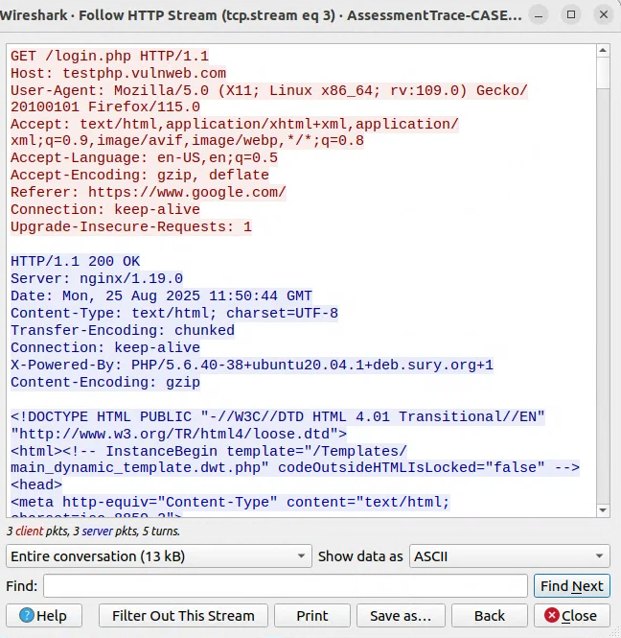
This exploit would be extremely dangerous in a real-world healthcare system, where the data being managed is sensitive and protected under strict regulations such as GDPR and HIPAA. Exposing login details in this way could lead to data breaches, and the compromise of patient information, damaging both patient trust and the organisation’s reputation.

Mitigating methods result in protecting the login process to address such problems. Which firstly guarantee that all user server connections are encrypted using Transport Layer Security, with the website requiring HTTPS on every page. Stopping hackers from collecting credentials as they are being transmitted. Using algorithms like Argon 2 or Bcrypt, passwords should be encoded & hashed using strong algorithms, making them unreadable even if the data base is stolen, resulting in passwords not being kept in plain text or sent in plain text (OWASP, 2021). A second verification, for example, time-based code & a multi factor authentication may offer an additional layer of safety creating a reduction in password theft. The encouragement of the use of password managers, strong password rules should be enforced by organisations, they should also restrict weak & previously compromised passwords.
In healthcare, these measures are essential to safeguarding sensitive patient data, which are kept in digital health record systems in addition to user accounts. If an attacker manages to obtain any network access, however the usage of HTTPS & password hashing makes it extremely difficult for them to exploit & read credentials which have been taken. Furthermore, as human error often leads to breaches, user awareness training and frequent security audits are equally crucial. Healthcare systems can lower the risk of compromised accounts and maintain compliance with data protection regulations, by combining technical measures with strict policies. If passwords are exposed, then session hijacking, credential theft and unauthorised access to patient data & systems may occur.
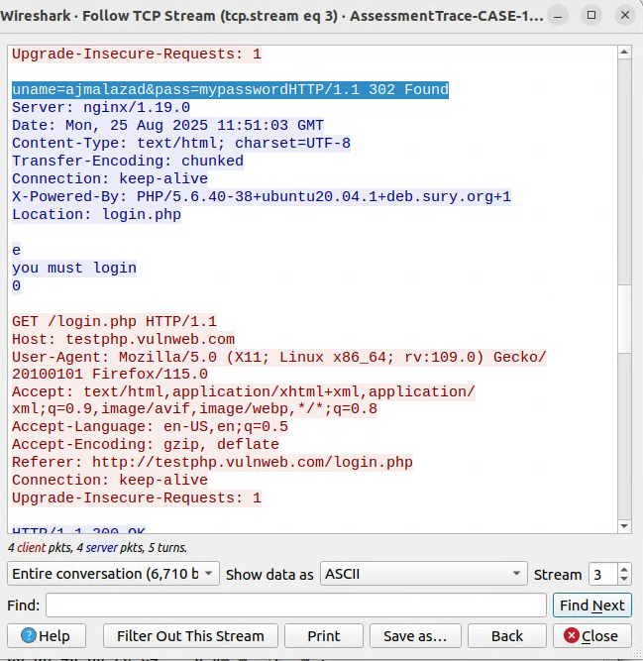

Case-2 Web and Software Level Attacks
Task 1:
A SQL Injection attack on MediCare Innovations’ EHR or telemedicine system could happen if the platform does not properly check what a user types into a search box or URL. If the system allows someone to look up a patient by searching their patient ID, and if this input is not validated, an attacker can take advantage of it. The field may be evaluated with a single quote to see if the system reacts unexpectedly, indicating that the input is being placed directly into a database query. Once they know it is vulnerable, they could type something like ' OR '1'='1 instead of a real ID. When the system builds the SQL query, it accidentally creates a statement that returns every patient record because the condition '1'='1' is always true.
Meaning that a single line of text may give an attacker access to patient information, not just a person’s record. The attacker could enter even more damaging inputs such as, ‘DROP TABLE patients’, which could delete entire tables and remove medical data, if the database account has higher permissions. Meaning that consequences are dangerous, since sensitive patient information clinical records could be deleted or changed, & parts of systems may stop working. Affecting Integrity, Confidentiality, & availability all at once, showing how an unchecked input box may put the entire healthcare system at risk.
Task 2:
Three crucial tactics to mitigate SQLi vulnerabilities in web apps should be employed by MediCare, to ensure that user input cannot be processed as part of a query. First, implement prepared statements and structured queries, which isolate user input from the SQL code itself (OWASP, 2021). Secondly, the system should check and clean everything a user types in, making sure it only allows the kind of input it expects. This helps stop harmful commands from getting into the database (Esposito, 2019).
Thirdly, ensure the web applications can only access the data that they need and don’t have admin right. This way, even if a SQL injection happens, the damage will be limited (Verizon, 2025). These measures lower all possibilities of hackers who may be able to take advantage of the SQLi flaws, protecting data integrity, patient privacy & ensuring the accessibility of medical services. Putting these methods into effect, allows healthcare system to stick to cybersecurity practices & comply with all data protection laws.
Task 3:
A buffer overflow happens when a software writes more data into a fixed-size memory buffer than it was allocated for, overwriting nearby memory areas such as variables or return addresses, causing unwanted program execution changes (OWASP, 2025). This would occur if MediCare Innovations devices & monitoring software accepts network data without any boundaries checking. Malicious code could potentially get put onto a device through a large data transfer over Bluetooth, Wi-Fi, & a mobile interface by an attacker. Resulting in unauthorised access to patient data in real time, modification of vital sign alarms, & the extraction of private health information.
A similar memory safety issue may be seen in OpenSSL's Heartbleed vulnerability (CVE-2014-0160). Heartbleed was a buffer over-read, where a faulty heartbeat request claiming more data than sent led the server to return up to 64KB of memory, revealing private keys, session IDs, and other sensitive information (CISA, 2014). In MediCare Innovations' software, an identical ignored area might reveal patient information such as heart rates or device identification. Strategies for mitigation include input validation & bound checking, with the use of safe memory functions & current memory protections such as stack warnings, address space layout randomisation, & complier level security flags like -fstack- protector (Wiz, 2025). Regular code audits and static/dynamic analysis help to reduce risk and preserve patient data.
Case 3: Security and Privacy Analysis of Healthcare Applications
Task 1:
The types of permissions users have, create a significant impact on how securely healthcare apps manage private information (Shojaei, Vlahu-Gjorgievska and Chow, 2025). With apps such as, Google fit, Samsung Health, Fitbit, and more, of which ask for access to a variety of things, location, camera, contacts, & storage. These frequently asked permissions are unnecessary; however, some features are required like, activity monitoring & wearable data syncing. For instance, a basic step counting application does not require access to a user's contact list or microphone. With a danger of disclosing information to outside parties, by apps that request more permissions than necessary.
If these permissions are misused, it could create a major security & privacy problem, then when a healthcare app gathers location data, it would possibly accidently give away a user’s residence or client visits, creating an exploitation for targeted advertisement (Schroeder, Haug and Gewald, 2021). Certain programs keep gathering background information, even without explicit user authorisation. This over collection of data harms patient privacy and could destroy trust in digital health services. Due to this, developers must follow the least privilege principle, asking for rights that are only necessary, making sure users are aware of the reasons why access is required before providing it.
Task 2:
Application | Number of  Downloads | Version | Permissions | Possible  Dangerous  Permissions | Trackers
Samsung Health | 1B+ | Version 6.30.5.105 | Location, Camera, Bluetooth, | Location, Camera, Storage / Files | OpenTelemetry (OpenCensus, OpenTracing)
MyFitnessPal | 100M+ | Version 25.43.0 | Camera, Read Contacts, Record Audio | Contacts, Camera, Microphone, Call Logs & Phone, Storage / Files | Amazon Advertisement, Amplitude, AppsFlyer, Branch, Brightcove, Facebook Analytics, Facebook Login, Facebook Share, Google AdMob, Google Analytics, Google CrashLytics, Google Firebase Analytics, Google Tag Manager, IAB Open Measurement, Split, Unity3d Ads
Google Fit | 100M+ | Version 2025.09.25.00 | Location, Camera, Find Accounts | Location, Camera, Storage / Files | None
Fitbit | 50M+ | Version 4.53.1 | Location, Phone Calls, Bluetooth, Body sensors, Camera, Find Accounts | Location, Camera, Call Logs & Phone, Storage / Files | None
HealthTap | 10M+ | Version 24.3.0 | Location, Camera, Bluetooth, Record Audio, Read Phone Status | Location, Camera, Microphone, Call Logs & Phone, Storage / Files | Amplitude, AppsFlyer, Braze (formerly Appboy), Google CrashLytics, Google Firebase Analytics

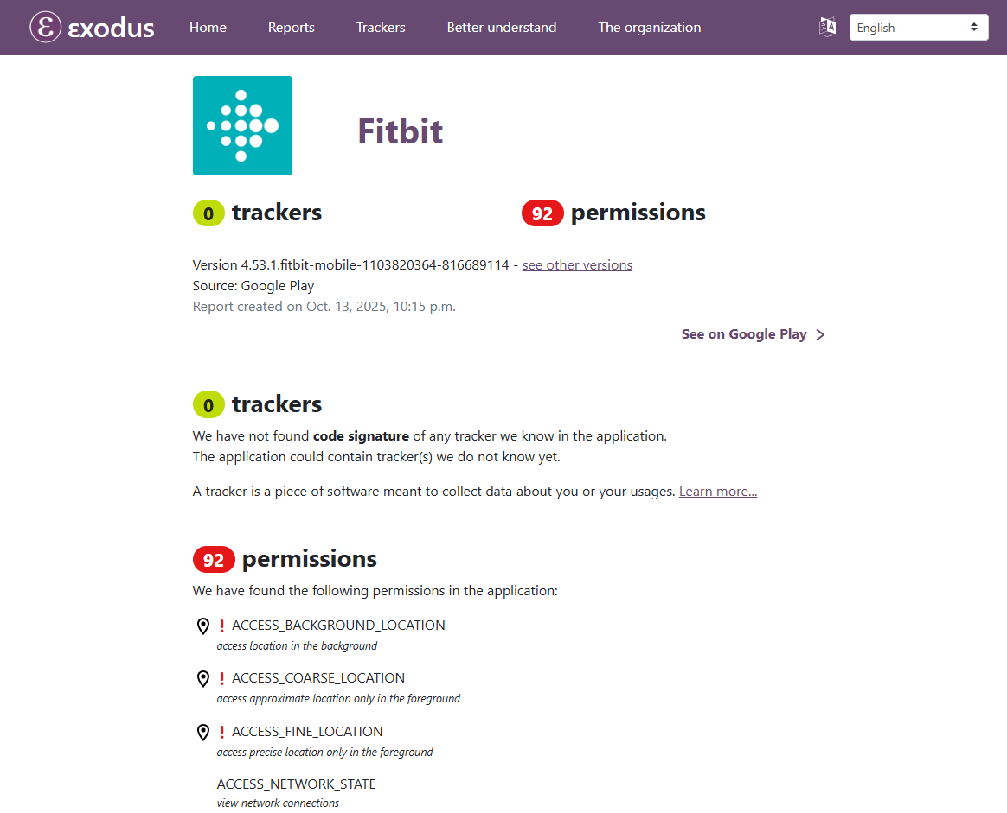

Analysis:
Research revealed that healthcare applications ask for many different types of permissions, and they might not explicitly be required for their primary operations. Some apps ask for location & contact information such as, Samsung Health & MyFitnessPal, which might be problematic if managed improperly. With there being different trackers that allow third parties to access user activity & health data, like Google Analytics & Facebook SDK. Providing results that emphasise the
significance of use knowledge, data transparency, & permission blockages in healthcare applications.
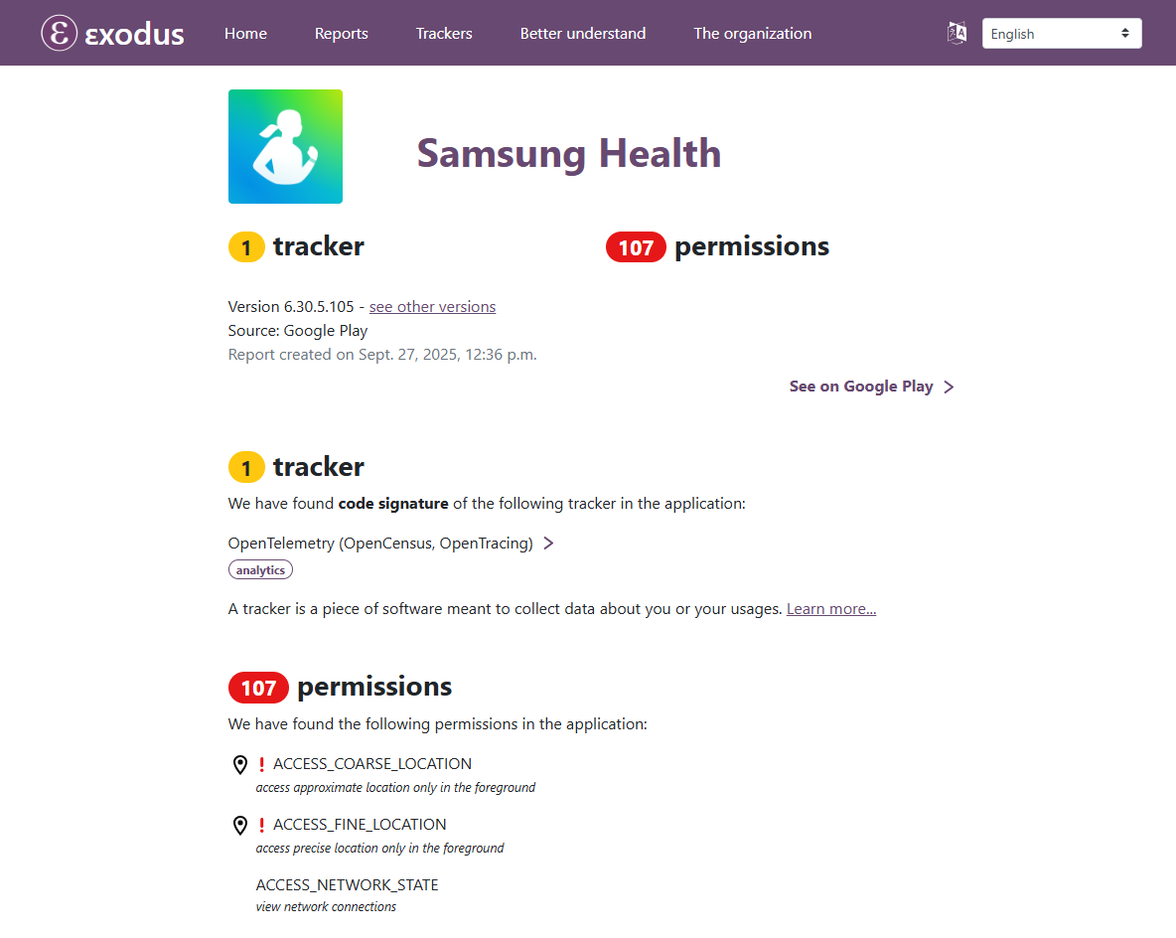

Task 3:
Mitigation Strategies for Permission Related Vulnerabilities:
Developers should limit app permissions which follow the principle of the least privilege, to limit permission related risks in healthcare mobile apps. To reduce the risk of a data leak, the app only requests permissions needed to perform its core functions. For example, a hear rate monitoring app does not need any access to your camera or your contacts unless you request a certain feature. To help spot and remove unwanted or dangerous remissions, regular checks and code reviews will help, any misuse of permissions could cause malicious exploitation & unintended disclosures of sensitive health data (Gallagher, 2015).
Providing control & clarity to users, involves clarifying why each permission is required, giving users control over them through prompts & privacy dashboards. Any authorised data must be securely stored and encrypted, adding regular security tests like privacy & check assessments for over-per missioning, ensuring that vulnerabilities are identified before the app is developed (Borky and Bradley, 2019). The mitigations mentioned above enhance the security of the application, creating user trust, and complying with any regulations, whilst protecting health information.

Case 4: Vulnerability Analysis and Responsible Disclosure
Task-1
CVE-2021-39376 is a SQL injection vulnerability in Philips Tasy EMR version 3.06, existing in the CorCad_F2/executaConsultaEspecifico function and its parameters, including IE_CORPO_ASSIST and CD_USUARIO_CONVENIO. When the application fails to properly validate user input, then the vulnerability is triggered, allowing an attacker to send SQL commands to the database. Indications point to it being exploitable, requiring low privileges, no user interaction and impacts all three areas of the CIA triad due to the base score being 8.8 with metrics AV:N / AC:L / PR:L / UI:N / S:U / C:H / I:H / A:H, according to CVSS v3.1. The CIA is high, due to patient records being accessed without authorisation, medical data being modified or deleted, and the attack may disrupt database operations or take parts of the MR offline.
This poses serious risk to hospital operations and patient safety, because SQL injection allows direct access to sensitive data, modification of critical records, and potential system downtime. For effective strategies, mitigation hospitals should apply the Philips update to version 3.06.1804. Long term fixes include applying the least privilege principle to database accounts, using queries & strong input, doing regular code reviews & security audits, as well as monitoring for suspicious activity. On the other hand, the short-term fixes would include enabling Web Application Firewall to block SQLi attempts & adding strict input validation. Demonstrating the vulnerability of CIA but giving the ability to strengthen the overall security of the EMR system & any sensitive health information that there may be, reducing the risk of any future attacks.
CIA Impact Levels for CVE-2021-39376

CVE-2021-37166 is a buffer overflow vulnerability in the HMI3 Control Panel used in Swisslog hospital pneumatic tube systems. An attacker can trigger the vulnerability because when the panel opens a network socket on all interfaces without proper checks, then this may cause the panel software to crash or stop functioning. This primarily affects availability with low impact on confidentiality and integrity, meaning it is vulnerable and requires low privileges & no user interaction, with a base score of 7.5 and metrics AV:N / AC:L / PR:L / UI:N / S:U / C:L / I:L / A:H, according to CVSS v3.1.
Confidentiality & Integrity are low due to the vulnerability not allowing the attackers to access patient data, and patient data not able to be modified, however availability is high because the system can be taken offline, which could lead to disruptions in hospital operations & delay critical tasks like transporting medications or lab samples. Updates to the HMI3 Control Panel software to version 7.2.5.7 or later should be done by hospitals, to restrict network access to any trusted devices, as well as to block untrusted connections using firewalls or access rules for immediate impact. Long term changes can involve creating software that will listen on necessary network interfaces only, checking for memory & buffer overflow issues, checking logs for suspicious activity. To ensure the tube system remains reliable & hospital operations continue, the long-term changes will help to prevent an attack in the future.
CIA Impact Levels for CVE-2021-37166
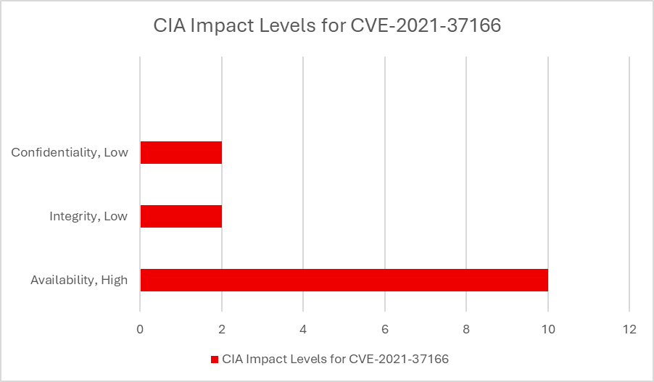

CVE-2020-25179 affects a range of GE Healthcare imaging and ultrasound devices. The vulnerability is that some of these devices may transmit credentials or sensitive system information over the network without proper protection, meaning that login credentials or maintenance‑access credentials could be exposed in flight. According to public vulnerability data, this issue has a CVSS v3.1 base score of 9.8 with vectors AV:N / AC:L / PR:N / UI:N / S:U / C:H / I:H / A:H, indicating a network‑accessible flaw with low complexity, no required privileges or user interaction, and high impact on confidentiality, integrity, and availability. If exploited, an attacker who gains network access could intercept credentials and use them to log into devices so Confidentiality is High (patient or device data could be exposed), Integrity is High (an attacker could modify or delete system or patient data, or mis‑configure the device), and Availability is High (an attacker might disable the imaging devices or otherwise disrupt their operation, potentially preventing scans or treatment).
To mitigate this risk immediately, organisations should isolate or segment medical imaging devices on protected networks, to ensure that communication channels are encrypted (e.g. by using VPNs or secure tunnels), and change any default or exposed credentials to strong, unique ones. For long-term protection, GE and hospitals should ensure secure transport protocols, enforce strict credential handling (no plaintext credentials), apply access control and logging, and regularly audit and monitor device communications for suspicious activity. These steps not only address the immediate credential exposure risk but also strengthen the overall security posture of medical imaging infrastructure and help protect patient data from unauthorised access or tampering.
CIA Impact Levels for CVE-2020-25179

CVE-2025-49704 is a code-injection / remote code execution vulnerability in on premises installations of SharePoint Server. Allowing attackers to import malicious code which the server will run, giving them full control over the SharePoint with access to all stored documents & data. This vulnerability has a base score of 8.8. with metrics indicating that is it exploitable, which requires low privileges, creating a high impact on Confidentiality, Integrity, & Availability (AV:N / AC:L / PR:L / UI:N / S:U / C:H / I:H / A:H). CIA is high, due to the attackers being able to read or steal any sensitive, they can modify, delete documents or configurations, & executing malicious code, which could crash the service, disrupt access, or completely compromise the server.
To mitigate this risk quickly, organizations should apply the latest security patch for SharePoint, isolate or shut down any publicly facing SharePoint servers until patched, and enable endpoint protection on the server. For the long term, best practices include enforcing strict input validation and safe code generation, disabling unneeded code generation features, running SharePoint under least privileged accounts, enabling runtime defences (sandboxing, anti-malware), monitoring logs and file integrity, and keeping up with regular security audits and patch management. These are to help eliminate the vulnerability & build a stronger defence against future code injected attacks.
CIA Impact Levels for CVE-2025-49704

Task 2:
To ensure patient safety while making sure problems are quickly resoled, revealing vulnerabilities in critical networks is key, such as, healthcare platforms. Enabling researchers to report the vulnerability to the vendor, allowing the vendor time to create & produce a patch before any information is made publicly available. Full disclosure may be required, yet there is greater risk of exposure, & data breaches within the healthcare industry, with rare instances where the vendor declines to act. In healthcare, full disclosure is less likely to be preferred over responsible disclosure because reporting a vulnerability privately to the vendor first prevents attackers from exploiting the issue before a fix is available, protecting both the critical medical systems and protecting patient safety.
Timing is crucial when identifying and verifying vulnerabilities, gathering evidence, conducting assessments, alerting vendor of technical details, creating responsible repair windows, and organising public disclosure once the patch is available, so a structured timeline must be followed.
Communication must be clear, and recorded during this process, particularly when interacting with healthcare providers or officials, due to the systems being connected to patient data, medical devices, & critical services. Which leads to a reduction in patient risk, involving prevention to any testing that might conflict with live systems, ensuring that disclosure does not reveal any operational flaws, whilst collaborating with supplier to distribute updates & warnings in a way that does not interfere with services. Guaranteeing that the vulnerabilities are managed morally, securely, and in a way that safeguards the patient welfare & integrity within the system.

Conclusion:
This report demonstrates just how vital strong software security is in healthcare, where weaknesses can put patient data and services at serious risk. The assessment of MediCare Innovations shows that protecting sensitive information depends on spotting vulnerabilities early and addressing them responsibly. Because healthcare systems handle highly sensitive data, even small flaws can have real world consequences. By maintaining effective security practices, applying updates promptly, and handling vulnerabilities carefully, healthcare providers can reduce risks and maintain trust in their digital systems. Ultimately, ongoing vigilance and proactive security are essential for safeguarding both patient information and the integrity of healthcare technology.

References:
BBC News. (2017) NHS cyber-attack: Everything you need to know about WannaCry. Available at: https://www.bbc.com/news/technology-39901382
BBC News. (2017) Equifax data breach: How 147 million customers were affected. Available at: https://www.bbc.co.uk/news/business-41192163
Verizon. (2025) 2025 Data Breach Investigations Report. Available at: https://www.verizon.com/business/resources/reports/dbir/
IBM Security. (2024) Cost of a Data Breach Report 2024. Available at: https://www.ibm.com/reports/data-breach
NIST. (2018) Framework for Improving Critical Infrastructure Cybersecurity. Available at: https://www.nist.gov/cyberframework
NIST (2019). NVD. [online] Nist.gov. Available at: https://nvd.nist.gov/.
Abernethy, A., Adams, L., Barrett, M., Bechtel, C., Brennan, P., Butte, A., Faulkner, J., Fontaine, E., Friedhoff, S., Halamka, J., Howell, M., Johnson, K., Long, P., McGraw, D., Miller, R., Lee, P., Perlin, J., Rucker, D., Sandy, L. and Savage, L. (2022). The Promise of Digital Health: Then, Now, and the Future. NAM Perspectives, [online] 6(22). doi:https://doi.org/10.31478/202206e.
NS Commercial (2025). The struggle to keep pace with the rise in cyberattacks. [online] New Statesman. Available at: https://www.newstatesman.com/spotlight/tech-regulation/cybersecurity/2025/12/the-struggle-to-keep-pace-with-the-rise-in-cyberattacks
Bernstein, G. (2025). HIPAA Security Risks in 2025: A New Era of Digital Healthcare. [online] CloudTweaks. Available at: https://cloudtweaks.com/2025/02/hipaa-security-risks-in-2025-a-new-era-of-digital-healthcare/.
Iott, B.E., Campos-Castillo, C. and Anthony, D.L. (2020). Trust and Privacy: How Patient Trust in Providers is Related to Privacy Behaviors and Attitudes. AMIA Annual Symposium Proceedings, [online] 2019, pp.487–493. Available at: https://pmc.ncbi.nlm.nih.gov/articles/PMC7153104/.
NHS England (2022). Personal Data Breaches. [online] NHS Transformation Directorate. Available at: https://transform.england.nhs.uk/information-governance/guidance/personal-data-breaches/.
Cloudflare (2025). What is HTTPS? Cloudflare. [online] Available at: https://www.cloudflare.com/en-gb/learning/ssl/what-is-https/.
OWASP (2021). Password Storage - OWASP Cheat Sheet Series. [online] cheatsheetseries.owasp.org. Available at: https://cheatsheetseries.owasp.org/cheatsheets/Password_Storage_Cheat_Sheet.html.
Esposito, L. (2019). All Input Data is Evil-So Make Sure You Handle It Correctly and with Due Care. [online] CODE. Available at: https://www.codemag.com/article/0705061/All-Input-Data-is-Evil-So-Make-Sure-You-Handle-It-Correctly-and-with-Due-Care.
OWASP. (2021) OWASP Top Ten Security Risks. Available at: https://owasp.org/www-project-top-ten/
CISA, 2014. OpenSSL Heartbleed Vulnerability (CVE-2014-0160). Available at: https://www.cisa.gov/news-events/alerts/2014/04/08/openssl-heartbleed-vulnerability-cve-2014-0160
OWASP, 2025. Buffer Overflow. Available at: https://owasp.org/www-community/vulnerabilities/Buffer_Overflow
Wiz, 2025. Buffer Overflow: What It Is and How to Prevent It. Available at: https://www.wiz.io/academy/buffer-overflow
Shojaei, P., Vlahu-Gjorgievska, E. and Chow, Y.-W. (2025). Enhancing privacy in mHealth Applications: A User-Centric model identifying key factors influencing Privacy-Related behaviours. International Journal of Medical Informatics, 199, p.105907. doi:https://doi.org/10.1016/j.ijmedinf.2025.105907.
Schroeder, T., Haug, M. and Gewald, H. (2021). Where Does All the Data Go? The Data Privacy Concerns of Mature Adults Using mHealth Apps and Smart Speakers. (Preprint). JMIR Formative Research, 6(6). doi:https://doi.org/10.2196/28025.
Gallagher, L. (2015). Information handling by some health apps not as secure as it should be. [online] Imperial College London. Available at: https://www.imperial.ac.uk/news/167866/information-handling-some-health-apps-secure/?utm_source=chatgpt.com.
UCL (2024). Female health apps misuse highly sensitive data. [online] UCL News. Available at: https://www.ucl.ac.uk/news/2024/may/female-health-apps-misuse-highly-sensitive-data.
Borky, J.M. and Bradley, T.H. (2019). Protecting Information with Cybersecurity. Effective Model-Based Systems Engineering, [online] 1(1), pp.345–404. doi:https://doi.org/10.1007/978-3-319-95669-5_10.

